**Bikeshare Analysis**

My name is **Eyong, Wofai Alfred**. I am a data analyst tasked with performing a detailed analysis of the data of this bikeshare company. I have studied the bikeshare data and I am confident these actionable insights will help the company achieve its goal of strategic decision making.

**Introduction**

This company is a bike-share outfit, offering a fleet of bikes which can be unlocked at one station, used and returned to any other station in its ecosystem within 24-48 hours. Two customer type exist; Subscribers who purchase membership plans and non-subscribers who purchase single use passes. A clear goal of strategic business decision making has been set and to achieve this, historical bike trip data will be used to identify significant trends.

**Data**

The data was located in the company’s database and stored as a CSV file. This data is primary data collected by the company itself. This makes it highly reliable for this purpose

**Data Processing**

The CSV data was extracted and converted into .xlsx format. Microsoft Excel was used for data preparation, exploration and visualization. I chose this tool because of its versatility and data organization functions which makes insight generation easier.

I cleaned the data and prepared it for analysis.

Analysis was done using different excel functions and the pivot table.

**Results**

**Total Customers: 666**

**Customer Types**

**Out of 666 individuals who have used this service, 593 have subscribed, while 73 have not yet been converted to subscribers.**

**GENDER:**

**Total number of customers types by gender:**

|  |  |
| --- | --- |
| Male | 540 |
| Female | 126 |

**81% of users of the bike service are males while 19% of users are females. This shows that men currently use this service more than women.**

**A total of 126 female customers have used this service, 125 of them have subscribed to its long-term packages, while 468 male customers have subscribed with 72 yet to subscribe.**

**Although only *18.92%* of total subscribers are female compared to *81.08%* of males who currently use or subscribe to the service, we can see that females users have a higher subscription and retention rate of *99.21%* compared to males which have an *86.67%* retention rate. This means that if females are targeted and made to use the service, there is a higher chance of subscription.**

**Males recorded a higher trip duration compared to females**

**AGE:**

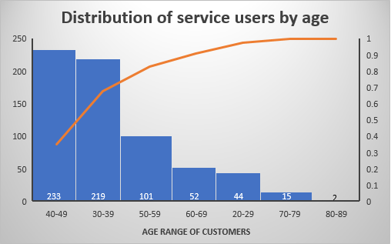

**The highest number of users fall within the age range 40-49 while the lowest number of users are above 80 years old. Marketing should target people at these higher end ranges**

**MONTH:**

**The highest use of the service was recorded in June while the lowest use of the service was recorded in January. This is likely connected to the weather and seasons of the year. Spring season is between March and June. This explains the progressive use from February to June.**

**WEEK:**

**Peak service use was recorded on Wednesday and Thursday closely followed for the weeks under review. Further investigation is required to understand the high traffic on both days.**

**DAY:**

**Peak ride order was observed at 17:00hrs daily. This is notably close of work time, hence the traffic.**

**TRIP STATIONS:**

**Central Park S & 6 Ave recorded the highest number of trips start when compared to other stations.**

**E 17 St & Broadway and E 7 St & Avenue A both recorded the highest trip end points when compared to other stations.**

|  |  |
| --- | --- |
| **START TO END TRIP STATIONS** | **FREQUENCY** |
| University Pl & E 14 St to Washington Pl & Broadway | 2 |
| W 26 St & 8 Ave to W 38 St & 8 Ave | 2 |
| W 20 St & 8 Ave to W 26 St & 8 Ave | 2 |
| Pershing Square North to W 33 St & 7 Ave | 2 |
| Rivington St & Chrystie St to W Broadway & Spring St | 2 |
| York St & Jay St to Rivington St & Chrystie St | 2 |
| Central Park S & 6 Ave to Central Park S & 6 Ave | 2 |
| Bayard St & Baxter St to Bayard St & Baxter St | 2 |

The 8 stations listed in the table above had two frequencies each. This was the highest trip frequency recorded.

**AVERAGE TRIP DURATION:**

The average trip duration is 814.7 minutes. This can be used to compare across individual trips in order to identify possible traffic congested areas.

**Non-Subscribers had a higher trip duration when compared to subscribers**

**RECOMMENDATIONS**

* Females should be targeted during advertisements as they have a higher retention rate. Fewer female use is also recorded compared to male counterparts.
* The spring season should be maximized as it is potentially the best time for the use of this service. Case studies have shown that the warm and dry weather encourages bikeshare use.
* More staff should be available to ensure smooth services during the peak period (June).
* Effort should be put into converting non-Subscribers to service subscribers. Adverts can focus on the health benefits as well as the reduction of pollution. This can serve as the needed nudge.
* More data should be collected by the company to aid analysis on a wider range of values
* Advertisements can be placed at high performing stations to encourage usage
* Bonuses and benefits can be used to boost performance in poor performing service stations.

**QUESTIONS**

1. What are the types of customers the company has and what is the count for each

2. Do men make use of the service than women?

3. What age group makes use of the bikeshare service the most?

4. What is the average trip duration?

5. What is the age distribution of customers?

6. What is the most common start station?

7. What is the most common end station?

8. What is the most common trip (start station to end station)?

9. What is the subscription rate among men and women?

10. What month records the highest traffic?

11. What day records the highest traffic?

12. What time records the highest traffic?

13. What customer type has the highest average trip duration?

14. What gender records the highest average trip duration?